import pandas as pd
import matplotlib.pyplot as plt
import seaborn as sns
import numpy as np
df = pd.read_excel("Cleaned_Sales_Dataset.xlsx")
df.head()
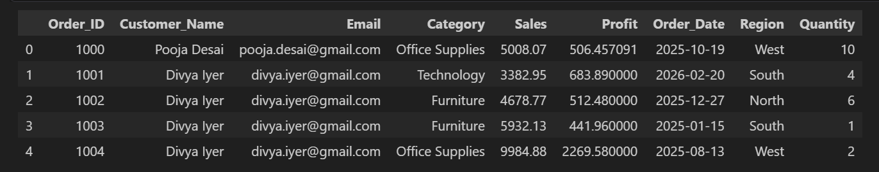

df.shape
(1175, 9)
df.info()
<class 'pandas.DataFrame'>
RangeIndex: 1175 entries, 0 to 1174
Data columns (total 9 columns):
# Column Non-Null Count Dtype
--- ------ -------------- -----
0 Order_ID 1175 non-null int64
1 Customer_Name 1175 non-null str
2 Email 1175 non-null str
3 Category 1175 non-null str
4 Sales 1175 non-null float64
5 Profit 1175 non-null float64
6 Order_Date 1175 non-null datetime64[us]
7 Region 1175 non-null str
8 Quantity 1175 non-null int64
dtypes: datetime64[us](1), float64(2), int64(2), str(4)
memory usage: 82.7 KB

df.describe()
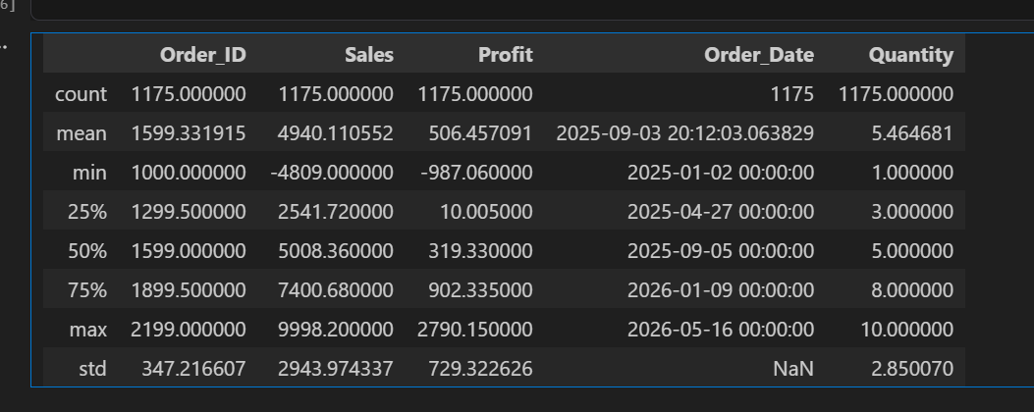

df.isnull().sum()
Order_ID 0
Customer_Name 0
Email 0
Category 0
Sales 0
Profit 0
Order_Date 0
Region 0
Quantity 0
dtype: int64

df["Category"].unique()
<StringArray>
['Office Supplies', 'Technology', 'Furniture', 'office supplies',
'technology', 'furniture']
Length: 6, dtype: str

df["Category"].value_counts()
Category
Office Supplies 395
Furniture 383
Technology 367
technology 12
office supplies 10
furniture 8
Name: count, dtype: int64

df["Category"].dtype
<StringDtype(storage='python', na_value=nan)>
df["Category"] = (
df["Category"]
.astype(str)
.str.strip()
.str.lower()
.str.title()
)
df["Category"].value_counts()
Category
Office Supplies 405
Furniture 391
Technology 379
Name: count, dtype: int64

Exploratory Data Analysis (EDA) on Sales Dataset

Visualization 1: Total Sales by Category
plt.figure(figsize=(6,4))

sns.barplot(
data=category_sales,
x="Category",
y="Sales"
)
plt.title("Total Sales by Category")
plt.xlabel("Category")
plt.ylabel("Total Sales")

plt.tight_layout()
plt.show()

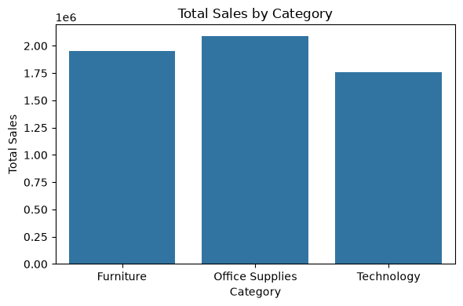

Purpose
This bar chart compares the total sales generated by each product category.
Insight
Office Supplies generated the highest total sales, followed by Furniture, while Technology recorded the lowest total sales. This indicates that Office Supplies is the strongest revenue-generating product category
Visualization 2: Total Sales by Region
plt.figure(figsize=(6,4))

sns.barplot(
data=region_sales,
x="Region",
y="Sales"
)

plt.title("Total Sales by Region")
plt.xlabel("Region")
plt.ylabel("Total Sales")

plt.tight_layout()
plt.show()

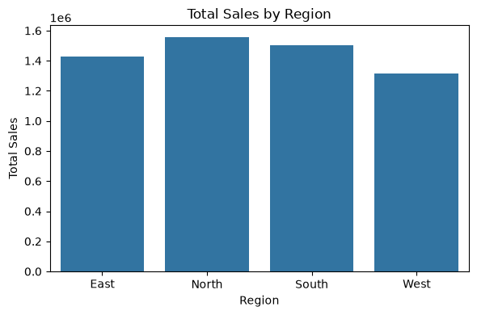

Insight
The North region generated the highest total sales, followed by the South and East regions. The West region recorded the lowest total sales. This indicates that the North region is the strongest market, while the West region may require additional marketing and sales strategies to improve performance.

Visualization 3: Profit Distribution

plt.figure(figsize=(6,4))

sns.histplot(
data=df,
x="Profit",
bins=20,
kde=True
)

plt.title("Profit Distribution")
plt.xlabel("Profit")
plt.ylabel("Frequency")

plt.tight_layout()
plt.show()
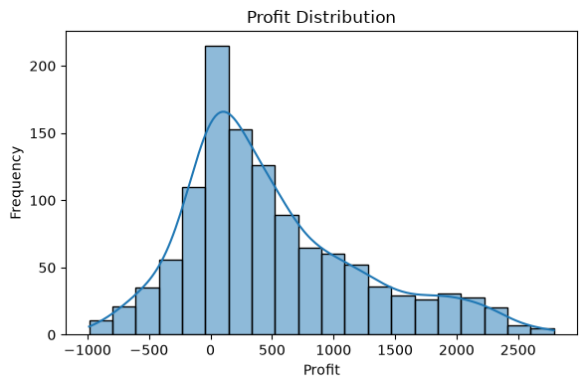

Insight
Most orders generated a profit between 0 and 500, indicating that the majority of sales produce low to moderate profits. A few orders resulted in negative profits (losses), while very high-profit orders are relatively rare.

Visualization 4: Sales vs Profit (Scatter Plot)

Code
plt.figure(figsize=(6,4))

sns.scatterplot(
data=df,
x="Sales",
y="Profit"
)

plt.title("Sales vs Profit")
plt.xlabel("Sales")
plt.ylabel("Profit")

plt.tight_layout()
plt.show()

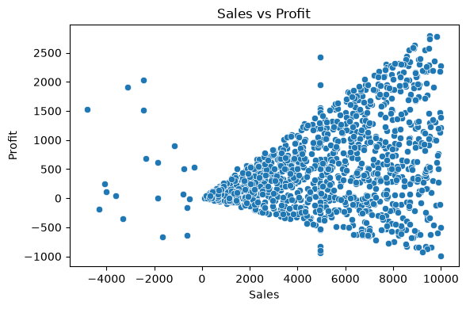

Insight
The scatter plot shows a generally positive relationship between sales and profit. As sales increase, profit tends to increase. However, a few orders with high sales still resulted in negative profit, indicating loss-making transactions.

df["Month"] = df["Order_Date"].dt.to_period("M").astype(str)
monthly_sales = df.groupby("Month")["Sales"].sum().reset_index()

monthly_sales
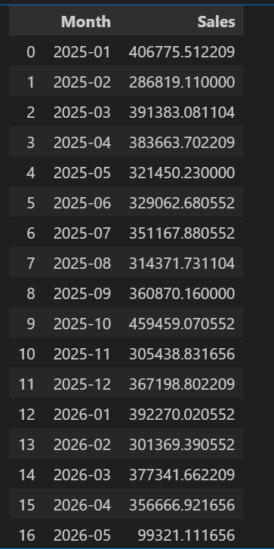

Visualization 5: Monthly Sales Trend (Line Chart)

Code
plt.figure(figsize=(7,4))
sns.lineplot(
data=monthly_sales,
x="Month",
y="Sales",
marker="o"
)
plt.title("Monthly Sales Trend")
plt.xlabel("Month")
plt.ylabel("Total Sales")

plt.xticks(rotation=45)

plt.tight_layout()
plt.show()

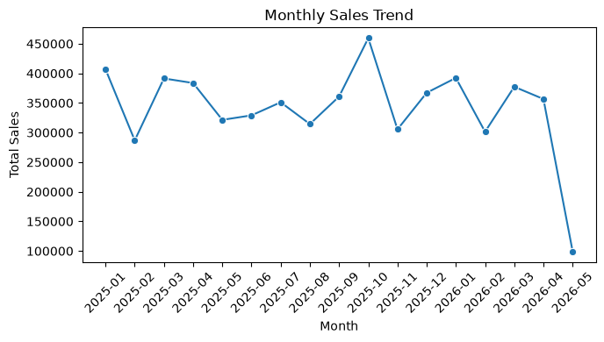

Purpose
This line chart shows how total sales changed over time on a monthly basis.

Insight
The monthly sales trend highlights fluctuations in sales across different months. It helps identify peak sales periods and months with lower performance, enabling better business planning and forecasting.

Conclusion
Exploratory Data Analysis (EDA) was performed on the cleaned sales dataset using Python libraries such as Pandas, Matplotlib, and Seaborn. Five visualizations were created to analyze sales by category, sales by region, profit distribution, the relationship between sales and profit, and monthly sales trends. These insights help understand business performance and support data-driven decision-making.

